Project List A



Contributors:

Sarah Olle, Vice President (Clubs and Services) 2009-2010

Alexanda Brown, Vice President (Internal) 2009-2010

Jose Diaz, Vice President (Finance and Operations) 2009-2010

Ivan Neilson, President 2009-2010

Kay Turner, President 2008-2009

Pauline Gervais, General Manager

Table of Contents

- Purpose
- Approval Rubric and Planning Process
- Interior Design
  - Interior and Exterior Signage
  - Artwork
  - Furniture
  - Advertisements
- Improvement Renovations
  - Cafeteria Lighting
  - Front Entrance Renovation
  - Banister Replacement
  - 3rd Floor Washrooms
  - Energy Audit and Renovations
- New or Modified Spaces
  - Break-Out Room
  - 4th Floor Meeting Room
  - SSMU Information Kiosk
  - Organic Campus Storefront
- Large Scale Revisioning
  - Voyage Campus
  - MTY
  - Gerts
  - New Building
- Appendices:
  - Appendix A: Go Maps of Shatner Building
  - Appendix B: Floor maps of Shatner Building (not totally up-to-date)
  - Appendix C: Energy Usage Report

Purpose
Herein are laid out several projects brainstormed during the 2008-2009 and 2009-2010 years. These projects seek to accomplish the objectives set out in the Vision for the Shatner Building.

This document should be followed up on intensely and vigorously: every incoming SSMU Executive should closely examine this document, follow through with any renovations currently underway, and begin any new projects which they deem to be appropriate.

The year 2011 will be the most important year in setting the vision for the next 5 years of the building because that SSMU Executive will define which lessees will sublet space from the SSMU. Other Executives after that should still work on these projects. Only through the vigilance of each SSMU Executive will these improvements be completed.

This document is entitled “Project List A” on the expectation that there will be a “Project List B”. In 2013, the incoming SSMU Executive should do a reexamination of the Shatner Building and formulate a “Project List B”. This list will have new projects which have not yet been envisioned but will greatly add to the quality of the Shatner Building.

Approval Rubric and Planning Process
When brainstorming new projects, the following test should be applied:

- Vision for the Shatner University Center
How does the project align with the Vision for the Shatner University Center? Which objective does it qualify under? Does it fit into both the short-term goals and long-term needs of the SSMU? If it does not qualify or interferes with the qualifications laid out, how is this justified?
- McGill University
Does the proposed project fit into the SSMU’s MOA and lease with McGill? Does it follow McGill’s guidelines and policies for buildings, signage, etc.? Has the Deputy Provost authorized the project?
- Financial feasibility
Does the SSMU have enough capital in the operating budget, CERF and/or IREF to support this renovation? Have these amounts been approved be the proper bodies? If not, has a fee levy been passed or another means to pay for the renovations been guaranteed? How will other departments be affected? Will the project have any positive or negative yearly impact on the SSMU operating budget once it is finished?
- Timeline
What timeline will work for the project? Will this greatly interfere with the general use of the building?

These questions should all be considered before endeavoring to begin any renovations. This is the general process any major project should follow. Please note: this process may vary depending on the nature and scope of the project.

- Brainstorm the project.
  - Contextualize it within the Vision for the Shatner University Centre. Ensure it fits within that document.
  - Speak with the Executives and General Manager. Discuss the idea with Councilors and any interested students. Gain consensus as much as possible.
  - Try to set a budget cap for the project. Remember, projects done through McGill Facilities cost 50% construction costs, 50% additional fees. In other words, any cost estimates should be doubled.
- Receive preliminary approval.
  - Inform the Deputy Provost’s office of your intentions. Be clear – the project has not been approved or initiated. Ensure the Deputy Provost is in theory on board with the plan before moving forward.
- Create a concrete proposal for the project.
  - Have the General Manager open a project with McGill Facilities, McGill Planning, or an external company for small projects.
  - Optional: Speak with the Associate Vice Principal (University Services) and/or the Director of Physical Planning about the project.
  - Meet with the project manager to discuss the exact specifications of what you would like to do. Try to work with the Project Managers who have already completed projects in the University Centre. Let the project manager know of your budget expectations, so they can tailor the project to meet your budget line.
  - Meet with the estimator to get an idea of what each piece will cost, tailored to your budget.
  - Review the final details, estimate, and timeline with the project manager.
  - Review the material samples for the project (paint colors, fixtures, etc.).
- Seek approval from McGill.
  - Seek approval from the Deputy Provost. Present all the details of the project for approval.
  - Depending on the project, it must also be approved by the Planning Office, the Secretariat, etc.
- Present the project to Council.
  - Seek approval for the project.
  - Seek approval for the funding for the project, which will likely be CERF or IREF. The procedures for securing these funding sources is laid out in the By-Laws and a McGill memo from December 2009, respectively.

Interior Design Improvements
These projects should be completed as soon as possible because they require less planning and move the Shatner Building easily towards being more student-friendly, environmental, and modern. They also can be completed within the constraints of our current budget without any budget revisions or lease modifications.

Exterior and interior signage
Goal: Update the exterior and interior signage to be clear, welcoming, and modern. Principle 2.

Exterior signage
Goal: New sign with SSMU name and logo outside
The exterior light-up sign is broken. The SSMU must have clear, visible signage, that identifies the Shatner Building as the SSMU Building and welcomes students to it.

Progress:
The SSMU has been working to get a new sign for a year now. We had drawings for a sign to be hung over the front entrance of the SSMU. We revised the plans several times due to changes made by McGill. In late November 2009, we finally received approval from the McGill Architecture Advisory Committee. However this plan was not approved by the Deputy Provost. A revised sign, on the left side of the front entrance on two large spandrels, has been approved by all parties.

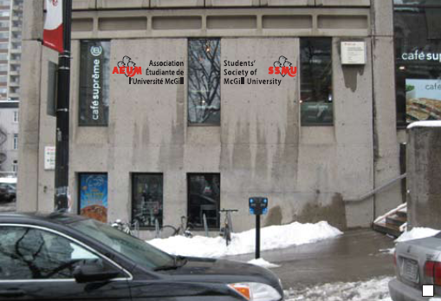
It is currently in production and should be installed by March 1, 2010.

Cost:
$8548 for the sign, plus $286 for the permit from the city

Interior signage - Stage 1
Goal: Update interior signage to clearly indicate various rooms throughout the building. Principle 2.
Design, produce and install: an up-to-date, attractive, and branded sign for the entrance, directive and clear signs throughout the building to meeting rooms, name plates on named rooms, and up-to-date floor maps of the building on each floor.

Progress:
Project completed. 18 signs designed, produced, and installed.
New floor maps designed, produced, and installed in back-lit cases.

Cost:
$5,376.00 for signs, plus installation.
$350 approximately for maps

Interior signage - Stage 2
Design, produce and install: more directive and name-plate signs and consistent number plaques for each room.

Progress:
16 signs plus 50 room number plaques in production. Should be installed by February 1, 2010.

Cost:
$5205, plus installation.

Artwork
Goal: Redo the artwork in the central staircase to be more attractive and SSMU-branded. Principle 2.
Remove the strange backlight artwork panels currently there. Replace with a huge white banner, 10 ft. by 15 ft., with both the SSMU and AEUM logo, framed by two narrower banners, roughly 5 ft by 15 ft., showcasing key photos from the past 100 years of student life on campus

Progress:
The design has been finalized in order to ensure the banners will not bend or discolor. The photos have been gathered and laid out in a mosaic fashion. The design has been approved by the Executive Committee. The banners have been hung.

Cost:
$3,770. This cost will be paid by Café Supreme, with a plaque hung showing their contribution.

Furniture
Goal: Buy new couches and chairs for the Student Lounge and Clubs Lounge in order to make the space more visually appealing and comfortable. Principle 2.
Clean the blue couches in the Student Lounge. Donate the other couches in the Student Lounge and the Clubs Lounge to charity. Replace them with new couches, similar to the blue ones in the Student Lounge. Put in small lounge areas with a small rug, couch, and lamp in the areas with tables next to the staircases. Consider the placement of computer stations in the student lounge or in other areas.

Progress:
Not begun

Timeline:
Executive Committee will decide on the items to purchase and order them. They will be placed by the end of February, 2010.

Advertisements
Goal: Create a policy to govern how tenants can advertise in the Building and incorporate this into all subleases. Principle 2.
The SSMU should draft a policy regarding where, when, and how the tenants in the building can advertise. Advertising should be minimal and discrete. Ideally there would be a directory to show where each food service is. The logos in the windows, sandwich boards, and other forms of obtrusive and competitive advertising should especially be reexamined. These privileges could only be taken away through the renegotiation of these leases, in 2011.

Progress:
Sandwich boards have been prohibited. A comprehensive policy has not been developed.

Improvement Renovations
These renovations improve existing structures in the Shatner Building to be more modern and appealing. They do not alter any major structures or use.

Cafeteria Lighting
Goal: Redo the lighting in the Cafeteria to be brighter, better looking, and more environmentally friendly. Principles 2 and 3.
Remove the current outdated, dim overhead lighting. Replace it with modern, standardized, environmentally friendly, brighter lighting.

Progress:
We have opened a project with McGill. We are awaiting on a plan and estimate.

Timeline:
To be completed before May 1, 2010.

Front Entrance Renovation
Goal: Construct a welcoming, modern entrance to the building to open the building to all students. Principle 2.
Abolish old decaying, rusted red half-wall along ramp. Reconsider front wall. Redo stairs to be more inviting and open. Incorporate areas of greenery between the stairs and the building for aesthetics.

Progress:
Not begun

Timeline:
The SSMU has spoken in brief with the Associate Vice-Principal (University Services) Jim Nicell and Director of Physical Planning Chuck Adler concerning this project. Both believed it would greatly enhance the overall project to incorporate these renovations with the McTavish Street renovation plan. Because the McTavish Street renovations are planned for this summer, the SSMU would like to incorporate this renovation into the plan. The front entrance of the building would work cohesively with the pedestrian-friendly sidewalk and green area in front of the building.
Ideally the SSMU will work on plans during the Spring semester in order to be ready for construction over the summer, to be completed by September 2010. This timeline is ideal to accommodate the lower foot traffic into the building in the summer.

Banister Replacement
Goal: Replace current large dark outdated wooden banister with a lighter, modern metal or plastic banister in order to bring more light into the building. Principle 2.
Remove the large wooden banister running the length of the stairwell in the building, from the 3rd floor until the basement. Install a light colored metal or plastic banister with a guard down to the floor on the stairwell. This will improve the light throughout the building because, although the large central staircase has a sunlight in order to bring in light, the dark wooden staircase that surrounds the central column of sunlight darkens the entire building.

Progress:
Plans: not begun

Timeline:
Undecided

3rd floor washrooms
Goal: Remodel 3rd floor washrooms to be modern, clean, and bright. Principle 2.
The 3rd floor washrooms should be remodeled in a way similar to the 1st floor washrooms. McGill completed these renovations several years ago, but did not deem the 3rd floor washrooms to be within the scope of the campus-wide washroom improvements. The SSMU should seek to get the 3rd floor washrooms to the same standards at the 1st floor washrooms.

Progress:
Plans: not begun

Timeline:
Undecided

Energy Audit and Improvements
Goal: Commission a thorough professional energy audit of the building. Principle 3.
The SSMU has commissioned BPR to do a professional energy audit of the Shatner Building. The SSMU has prioritized energy savings primarily, with a secondary goal of instituting green projects in the building with a long-term vision of creating a more sustainable building. We have received a preliminary draft and are awaiting the final version before incorporating the suggestions into the Project List. The SSMU hopes to apply to the Sustainable Projects Fund to pay for any major equipment replacement or renovations.

Progress:
The first draft was presented February 12. We are awaiting the final version.

Cost:
$16,984.00 for the study. A potential subsidy from Hydro Quebec of $6,165 to cover 50% of the costs to do the study (not including McGill Facilities costs or taxes) brings the total to$10,819.
The cost of the renovations suggested is unknown.

New or Modified Spaces
These renovations seek to alter structures within the Building for new, better uses. These modifications hope to make the Building as usable as possible for students’ increasing needs.

Break-out room
Goal: Create a semi-formal meeting room for clubs to use. Principle 1.
This plan seeks to create a semi-formal meeting room next to the Lev Bukhman room. This room can be used in conjunction with Lev Bukhman or on its own. Wall off the section of the cafeteria next to Lev Bukhman with sliding glass doors. Create a doorway opening up into the hallway. Install nice flooring, repaint, and redo the lighting.

Progress:
The SSMU has opened a project with McGill, confirmed the estimate, and finalized the products. The project should be put to tender and granted in March. The project is dated for completion by April 30.

Cost:
$71,700 from McGill Facilities and Minicucci architecture firm to create a formal meeting room beside the Lev Bukhman room. This quote includes demolishing the floor finishes, light fixtures, and an opening for a new door, vinyl floor tiles, glass door, folding partition wall, blinds on 5 windows, repainting and lighting. 54% of this cost is the actual construction, and 46% is additional fees.

4th floor meeting room
Goal: Modify the current Club Lounge and offices bordering it on the left side to create one large enclosed meeting room. Principle 1.
Clubs need more meeting rooms. The poor design of the club offices on the 4th floor greatly limits the number of meeting rooms available. There are dozens of tiny offices, which are not flexible at all. The Clubs Lounge, which was once used as an open flexible lounge, is even being booked as a meeting room due to the lack of space available. However it is an open space, not conducive to meetings.

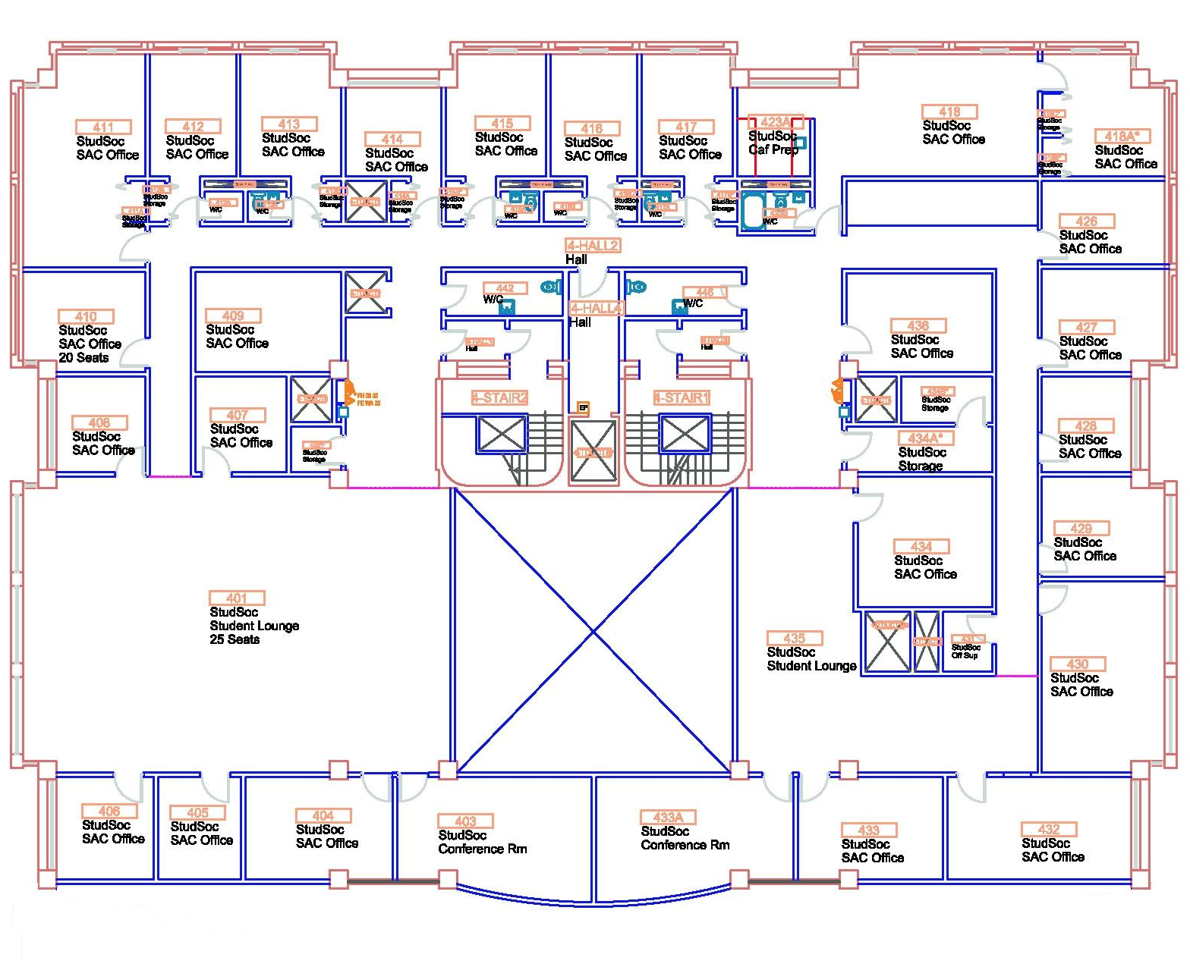
Current 4th floor plan

Accordingly it would be better to turn the Club Lounge and some of the offices bordering it into a large, enclosed meeting room, preferably with half windows to bring more light into the space and limit the effect of the many narrow hallways.

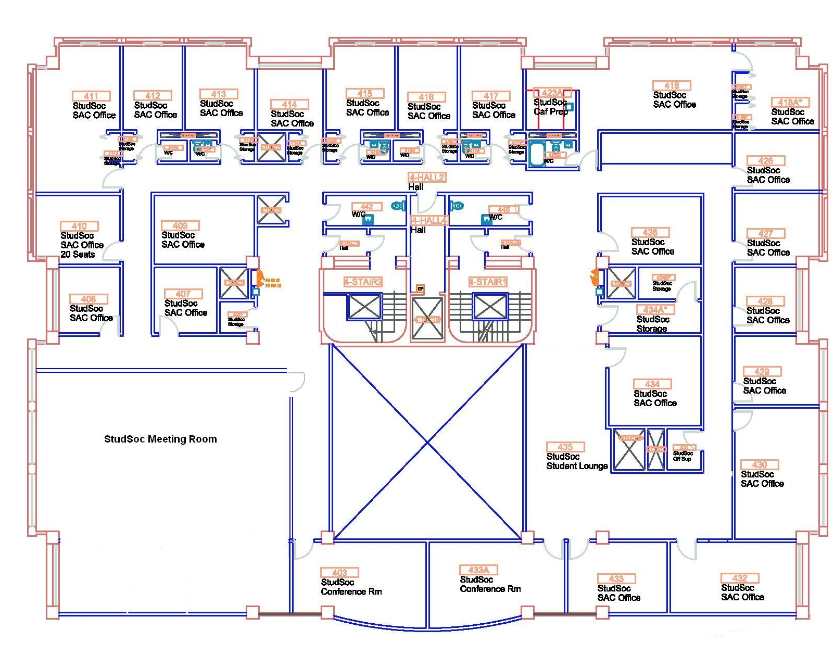
Proposed 4th floor plan

Progress:
Not begun

SSMU Information Kiosk
Goal: Remove largely unused kiosk in front lobby. Build a welcome center space in the middle of the central stairwell over current TV McGill office. Principle 1 and 2.
Remove kiosk and banister behind it. Build alcove over TV McGill that opens up into the lobby hallway. Frame it with two pillars to put the flat screens on. Ensure it has a gate to close it at night.
Put in information about SSMU, including brochures, forms, and photos. Use it to sell Old McGills, tickets to events, etc. It would be much like the original Sadies and provide a great service for students.

Progress:
Plans: not begun

Organic Campus storefront
Goal: Create a permanent store for Organic Campus. Principle 3.
As part of SSMU’s Five Year Plan for Sustainability, the SSMU has dedicated itself to working with its Organic Campus service to create a more permanent store in the Shatner Building. The store would remain a service, not a commercial operation.

Progress:
Organic Campus has received funding from the Generations Pact to do feasibility research. They are researching their product line, food permits, not-for-profit status, etc.
The Deputy Provost has been informed of the project. He is awaiting more details from the research before approving the project.

